Quick Tip: Complying with Characters per Inch Font Requirements
March 12th, 2013 in Law School / Legal Writing

Most legal research and writing courses and courts have strict format and stylistic requirements. One requirement that often causes problems is font size. Font size requirements can be confusing because they are often expressed in characters per inch (CPI) or pitch (e.g., 12 characters per inch, or 12 pitch).
If a course manual or court rule gives you a maximum CPI number, it is a strong indication you are expected to use a monospaced font like Courier New. Each character in a monospaced font takes up the exact same amount of horizontal space; while proportional fonts, like Calibri or Times New Roman, have variable character widths.
These CPI requirements are a holdover from the days of the typewriter but, once you understand them, are easy enough to comply with.
The easiest way to comply with pitch requirements is to do some very simple math.
 | Equation: Point Size = 120 ÷ Pitch

Therefore:
Size 10 Courier New = 12 characters per inch
Size 12 Courier New = 10 characters per inch
These are the most common font size requirements found in court rules and LRW stylistic requirements. Matthew Butterick, author of the excellent book Typography for Lawyers [amazon link], has compiled a handy list of court rules about typography here.
If you intend to use a proportional font and comply with a CPI requirement, a little measuring and trial and error will be required. For example, if you are attempting to comply with a 10 characters-per-inch requirement, you would measure a five-inch section of text and verify that it contains no more than fifty characters (counting spaces). For a 12 characters-per-inch requirement, you would measure a five-inch section of text and verify that it contains no more than sixty characters (counting spaces).
The following graphic illustrates the difference between a monospaced and proportional font and the sizes needed to comply with a CPI requirement. The shaded text indicates the first fifty characters of each sentence. The font sizes listed are a good starting point but you should still measure your text to verify compliance with court or course requirements.
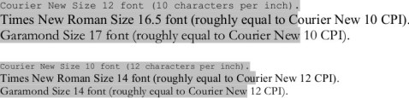
Monospaced vs. Proportional Font Sizes
http://www.persuasiveauthority.com/2013/03/12/quick-tip-complying-with-character-per-inch-font-requirements/

